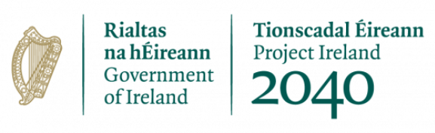

Request and Rationale for Pre-Funding

Pre-funding can be provided to Community Groups in very limited circumstances and on a case-by-case basis. Pre-funding will only be considered for Community Groups where a clear need has been identified and is evidenced by the Community Group to Meath County Council.

The Department of Environment, Climate & Communications has received sanction of the Minister for Public Expenditure and Reform for DECC to pre-pay up to a maximum of 25% of their approved allocation, as an advance payment, upon signing of their agreements with Meath County Council. This is subject to being satisfied that this is necessary and appropriate in the particular circumstances of an individual case and following an assessment of the needs of the Local Authority, taking account of the scale of the investment required in the early phase of the project and the ability of the Local Authority to fund this investment without an advance payment of the grant.

Under Public Financial Procedures and DPER Grants Circular 13/2014, pre-payment of grants should only arise where it is actually necessary, taking account of the grantee’s cash needs and the scale of expenditure required in the early stages of a project. In such circumstances, the use of the prepayment must be carefully monitored with any further advances only being paid on foot of vouched expenditure to show that the initial advance had been fully used, etc. In addition, any unused portion of such advance grant payments that remain unspent at year-end should be surrendered to the Exchequer.

If approved, the rationale presented for pre-funding will be retained by the Department for
audit/inspection purposes, together with the monitoring and control arrangements attached to the pre-funding, including for surrender of any unused balance at the end of the project. Subsequent grant instalments must be paid over the course of the project on the basis of milestones being achieved and on foot of submitted vouched expenditure to show that the initial advance had been fully used.

Note the below:
- This request will be reviewed and pre-funding may or may not be approved.
- No advance payment will be issued until a Final Letter of Offer has been issued and an agreement has been signed by the partner organisation.
- Any unused portion of such advance grant payments that remain unspent at the end of the project should be surrendered to the Department.
- The use of the pre-payment will be carefully monitored and recorded by Meath County Council.
- All subsequent drawdown requests will only be paid on foot of vouched expenditure which show that the initial advance had been fully used.
- Subsequent payments from the Community Climate Action Programme will be made over the course of the project on the basis of milestones being achieved. Payment schedule details will be included in the Grant Agreement.

Is pre-funding requested?
Yes | No

If pre-funding is requested, please provide a detailed rationale of need and cash flow analysis. This may include the following as part of the rationale put forward:
- the scale of expenditure required in the early stages of project delivery,
- evidence of limited ability of the grantee to fund the project without an advance grant payment
- the cash needs of the grantee
- specifically how the advance payment would be used
- please include/attach a cash flow projection to support this

Rationale for pre-funding (please complete)

Please state the amount requested (VAT inclusive) in Euro, as a percentage of the CAF funding (100% figure).

Amount of pre-funding requested – VAT inclusive (€)
As a % of the 100% CAF funding (1)
As a % of the 100% CAF funding and reduced by the applicable match funding rate

Declaration from applicant:

- I declare that the information given in this form is correct.

Name in block capitals (on behalf of group / organisation):

Signature:

Position held in group / organisation (block capitals):
Date:

