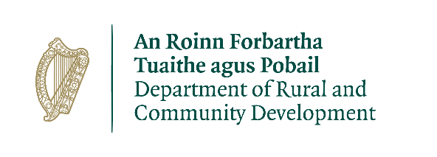

Community Recognition Fund 2024
Expression of Interest
The submission of an Expression of Interest will be assessed by Meath County Council and we will be in contact if the application has been deemed successful for the next stage of application process to the Department of Rural and Community Development.
Closing Date: 21st June, 2024

Contact Details Information

Name of Group/Organisation
Contact name for project
Address
Townlands
(i.e.Navan, Kells, etc)
Email

Telephone number

Project Details

Project Title
(e.g. Bally Tennis Club Resurfacing Works)

Project Description

Coordinates for location of project
(use ITM XY coordinates with
format: 123456.123
Project Address
(must be the address of the actual project and
include an Eircode where possible)
Project rationale

Outline the capacity of the group to deliver the project as outlined
(Include details of the track record of project
partners and experience of delivering similar
projects)
Identified needs this project will aim to address
Total Costs (€)
(total gross costs of the project including
any match funding)
Total Grant Sought (€)
(Min €50,000, Max €500,000 (per
project))

Rate of Aid Sought
(up to a max. of 100%)

Estimated Commencement Date
(dd/mm/yyyy)

Estimated Completion Date
(dd/mm/yyyy)
(50% of the proposed project must be
completed by 2025 and final project
to be completed by 2026)

Details of the requirement for funding
Outline gaps in community facilities/infrastructure in your area

Village/Town Name | Requirement for funding  Detail any gaps in community facilities/infrastructure

Project Details
Project Elements | Total Costs | Detail position re. the required consents/ permissions /ownership | Estimated Completion Date
Please list all elements of the proposed project. |  | Appropriate assessment, planning, land ownership etc. if not in place please specify and specify the est. timeline | (50% of the proposed project  must be completed by 2025  and final project  to be completed by 2026)
1. | €
2.
3.

Outline of how the proposed project will deliver tangible benefits to the community:
Has any element of this proposal previously been approved under any other Government Departments’ scheme:
If so, please outline

Use of Data
The information on this form will be used by Meath County Council for the purposes of processing the application. Further information may be sought by Meath County Council to clarify aspects of the project proposal. The form may be shared with other Government Departments for assessment purposes.

The Applicant and the Department are subject to the data protection and privacy laws of Ireland and the EU, in particular the Data Protection Act 2018 and Regulation (EU) 2016/679, known as the EU General Data Protection Regulation (“GDPR”). Any personal information which you provide as part of the application process will be obtained and processed in compliance with Data Protection legislation.

Meath County Council retains the right to disclose for the purposes of a request under the Freedom of Information Act 2014 or otherwise, in connection with the funded project(s) –
- any information supplied by the Applicant to the Department, and
- any relevant data gathered by the Department in administering grant aid to the project, except where the information is considered to be personal or commercially sensitive.

Declaration by Lead Applicant
This declaration must be signed by an authorised person i.e. chairperson, secretary.

I confirm that I have read and understood this document and declare that the particulars supplied in this funding proposal are true and correct and that –
- The costings are accurate and reasonable.
- All necessary permissions are in place e.g. planning consent etc.
- All relevant ecological survey work (if applicable) has been undertaken or will be undertaken e.g. Appropriate Assessment screen.
- There is evidence of ownership (if applicable) or the consent of the landowner.
- The project will comply with Public Procurement Guidelines.
- The project conforms to the LECP and other local or regional plans.
- No funding has been allocated for the same works from any other sources.

Proof of the above is not required at the time of application but must be available to Meath County Council, the Department or its agents on request.

I acknowledge the information regarding the use of data set out above and give consent to Meath County Council for the sharing of all information, personal or otherwise, contained in this funding proposal and any attachments accompanying it, in accordance with the uses of the data and information provided above.

Local Community Group: __________________________

Signature: _______________________________

Name in Block Capitals: __________________________

Position: _________________________________

Date: ___________________________________

